REPORT OF A ONE (1) DAY CONSULTATIVE MEETING WITH STAKEHOLDERS ON GOMBE STATE 2021 BUDGET HELD ON 17TH NOVEMBER 2020 AT THE CONFERENCE HALL OF COLLEGE OF NURSING AND MIDWIFREY GOMBE, GOMBE STATE.
- Opening Prayers
The meeting commenced with opening prayers from two volunteers at about 01:53pm followed by self-introduction of all participants/stakeholders.
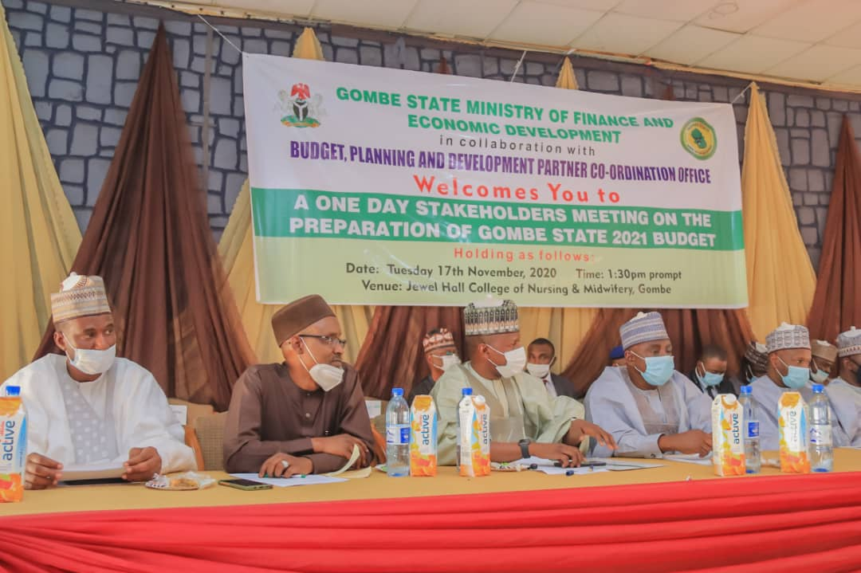
MEMBERS OF THE HIGH TABLE

- Welcome Address
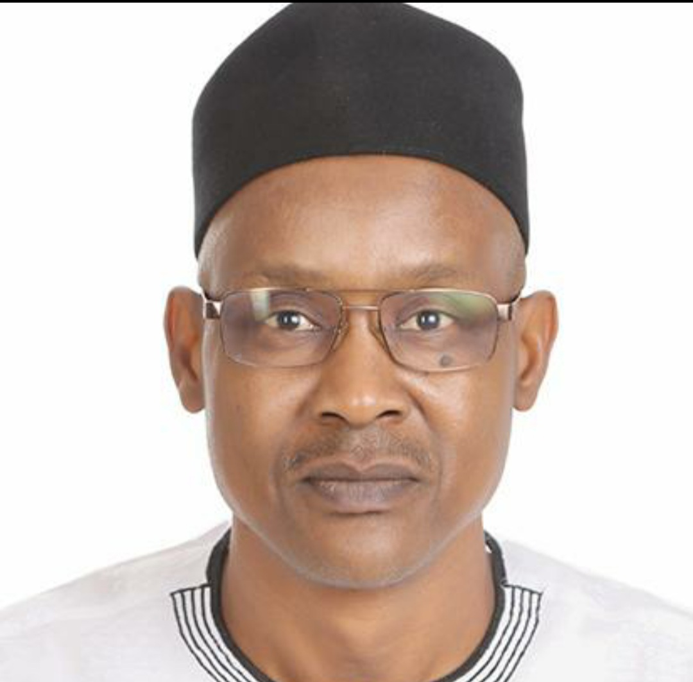
SPECIAL ADVISER TO THE GOVERNOR ON BUDGET, PLANNING & DEV’T. PARNER COORDINATION OFFICE
Welcome address was delivered by the Special Adviser to the Governor on Budget, Planning and Development Partner Coordination Office, Dr. Ishiyaku M. Mohammed who welcomed all especially His Excellency, the Governor for making it to the occasion despite their respective schedules. He wished all a fruitful discussion while praying for the safe return of all to their respective destinations.

- Goodwill Massages
Massages of goodwill were delivered by the Speaker, Gombe State House of Assembly Right Honourable Abukakar Sadiq Kurba; House Committee Chairman on Appropriation, Ali Baba-Manu as well as the Honourable Commissioner of Finance, Mal. Muhammad Gambo Magaji.

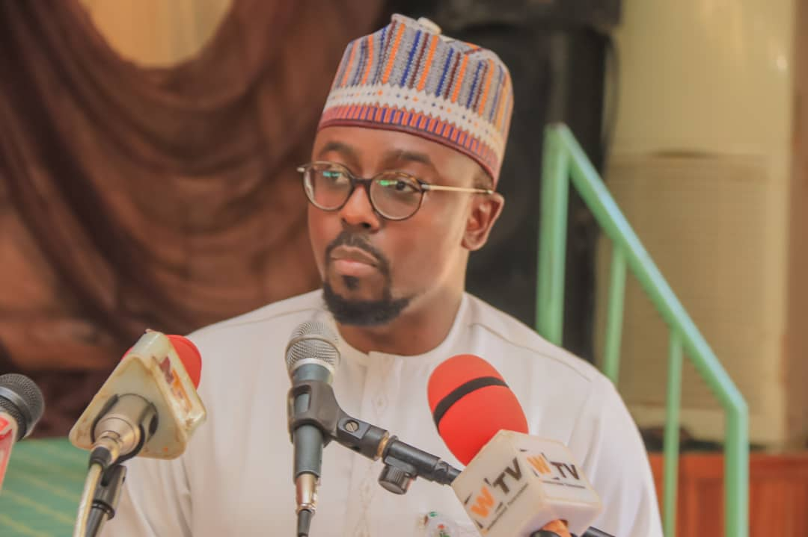
HONOURABLE COMMISSIONER OF FINANCE DELIVERING HIS GOODWILL MASSAGE
In their separate massages, both speakers drew the attention of the gathering on the importance attached to their active participation as well as suggestions and opinions. They commended the participants sense of patriotism, commitment to the progress of the State and wished all a fruitful deliberation.

- Opening Remarks
In his opening remark, the Governor of Gombe State, His Excellency, Alhaji Muhammadu Inuwa Yahaya stated that he was delighted to deliver an opening remark on the 2021 budget and is particularly happy to observe the level of interest of the people towards making meaningful contributions for the progress of the young state. This, he emphasized is delightful for him as a Governor who placed priority to such gatherings to impact on the live of the citizenry and to work on projects desired by the people themselves. His administration is committed to satisfying the yearning of its citizens and places high importance to good governance by listening to the voices of the people as drivers of change to the society at large. He promised that despite the downward economic situation of the world due to corona virus (Covid-19) pandemic, Gombe State Government is working assiduously to move the State forward.
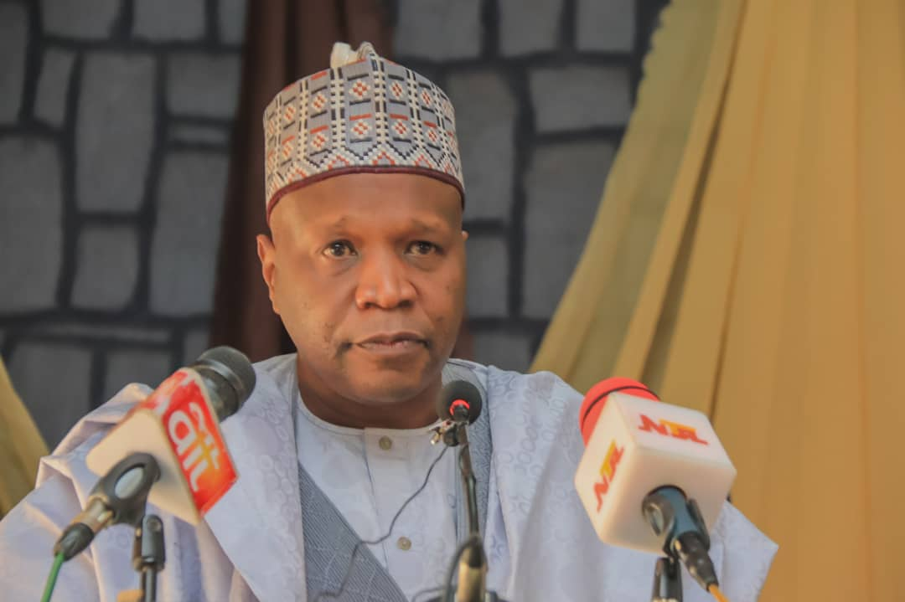
HIS EXCELLENCY, GOMBE STTAE GOVERNOR DELIVERING HIS OPENING REMARKS
The Governor while declaring the occasion open, assured the participants and government officials of his continuous support in this regard.

- Overview of the Gombe State 2021 Budget
While delivering his paper tittle “Overview of the Gombe State 2021 Budget” the Permanent Secretary, Budget, Planning and development Partner Coordination Office; Jalo Ibrahim Ali, stated that there are steps and milestones to reach in the preparation of annual budgets among which are: -
- Preparation of the State Medium-Term Expenditure Framework and Fiscal Strategy Paper (MTEF/FSP) Document.
- Submission of Medium-Term Expenditure Framework and Fiscal Strategy Paper MTEF/FSP to the State Executive Council (EXCO) for Review and Approval.
- Issuance of Fiscal Year (FY) 2021 Budget Call Circular.
- Submission of Budget Proposals to Budget Office by Ministries, Departments and Agencies (MDAs).
- Bilateral Budget Discussions with MDAs.
- Stakeholder Consultation (Civil Society Organizations, other stakeholders).
- Consolidation of MDA’s Proposals.
- Submission of Draft 2021 Budget to State Executive Council (EXCO).
- EXCO Review and Approval of Draft Budget.
- Presentation of the 2021 Proposed Budget to State House of Assembly.
- Budget Defense by MDA’s before the State House of Assembly.
- Debate and Approval of Budget by State House of Assembly.
- The Governor’s Assent FY 2021 Appropriation Law.
- Dissemination of 2021 Budget.
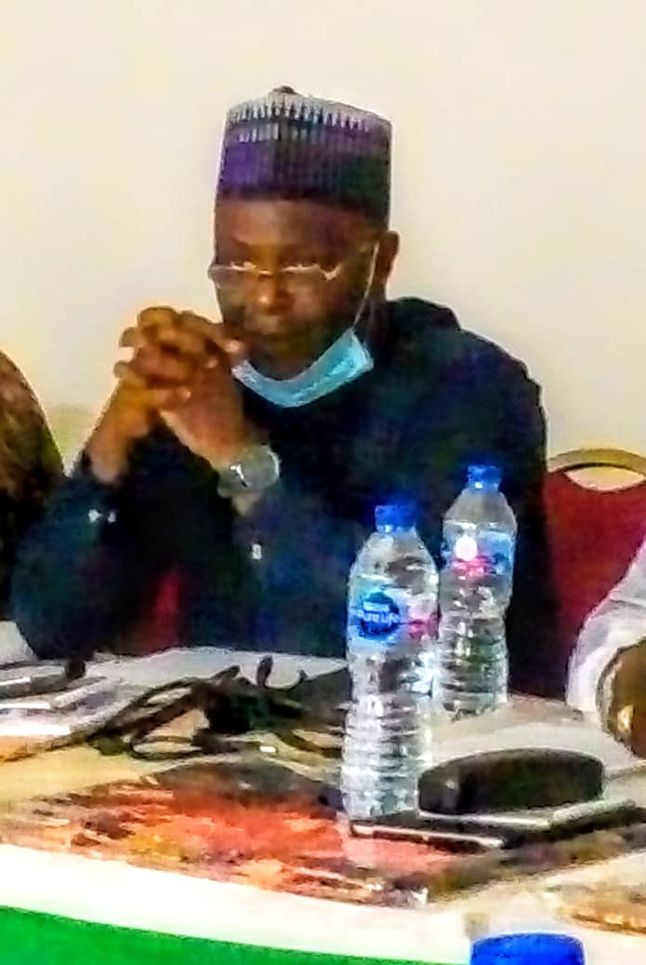
THE PERMANENT SECRETARY, BUDGET, PLANNING & DEV’T. PARNER COORDINATION OFFICE
Before dwelling on the 2021 budget, I would like to remind this gathering that in our meeting on 2020 budget consultation meeting last year, you suggested projects to be incorporated which saw the light of the day despite the drop in revenue occasioned by COVID-19 pandemic. Few among which include: -
In the area of Health;
- Improvement and equipping of Specialist Hospital Gombe.
- COVID-19 Intervention including construction, equipping of isolation centers, purchase of chemicals and reagents, purchase of Personal Protection Equipment, drugs and supplies. Testing, contact tracing, and tracking of patients, feeding, treatment, management and security and welfare of the centers and patient etc.
- Purchase of vaccines and sera.

In the area of Agriculture;
- Government has expended funds in animal disease control
- Improving the Wawa-Zange and other grazing reserves.
- Support to farmers generally by providing qualitative and cheaper fertilizer and improved seeds as well as agricultural chemicals.
In the area of Education;
- Continued funding of existing and new Secondary Schools in the State.
- Continued funding of the State Higher Institutions of learning including the universities.
In the area of Social Service;
- More than 700 Million Naira worth of Palliatives (food items, supplies and groceries) have been procured and distributed to the poor and vulnerable households all over the state to cushion the effect on the COVID-19 pandemic.
In the area of Infrastructure;
- Constructed several township roads, bridges, culverts and drainages within Gombe Metropolis while;
- Progressing on Gona-Garko-Kalshingi to Maidugu Road.
- Malala-Zaune-Dukkuyel Road.
- Dukku-Kalam-Dokoro-Jamari Road.
- Degri-Reme-Talasse Road.
- Bambam-Kutare-Loja Road
- Bambam-Yiri-Bwele-Kutuse Road.
- Mararraba Jabba-Sambo Layi-Pandi-Kolak-Gwaram-Gwanda Road.
- Ngaji Bauchi-Jurara-Lubo-Zambuk-Baure to Gwani and Kinafa Road.

In 2021, Government intends to: -
- Renovate and equip General Hospitals in Bajoga, Billiri and Kumo to serve as zonal COVID-19 treatment centers.
- Continue COVID-19 Interventions. Testing, contact tracing, and tracking of patients, isolation, feeding, treatment, management and security & welfare of the centres and patients etc.
- Continue Purchase of vaccines and sera.
- Provide free antenatal care
- Provide more funds in animal disease control, treatment and care.
- Provide more subsidies to farmers generally by providing qualitative and cheaper fertilizer and improved seeds as well as chemicals to boost dry season farming especially that this year the raining season farms have been affected by floods with low yields.
- Build one Model Secondary School in each Senatorial zone
- Ensure adequate funding of existing secondary schools
- Disburse hundreds of Millions of Naira each to cushion the impact of COVID-19 which eroded the working capitals of traders, artisans and businesses - both individuals, groups and associations like;
- Youth groups/associations
- Women groups/associations
- Micro, Small & Medium Enterprises.
After this presentation, the stage was now set for discussions, deliberations and contributions by participants and the floor was opened.
- Discussions & Contributions
- Stakeholders commended the government for having the masses at heart by gathering them in such fora and giving them the opportunity to contribute.
- They also thanked the government for giving value to their suggestions by capturing them into the State budget and assured the government of their maximum support and loyalty.
- Traditional rulers suggested that government should provide some operational funds to them on monthly basis to make them function effectively as the tasks of community administration is very high.
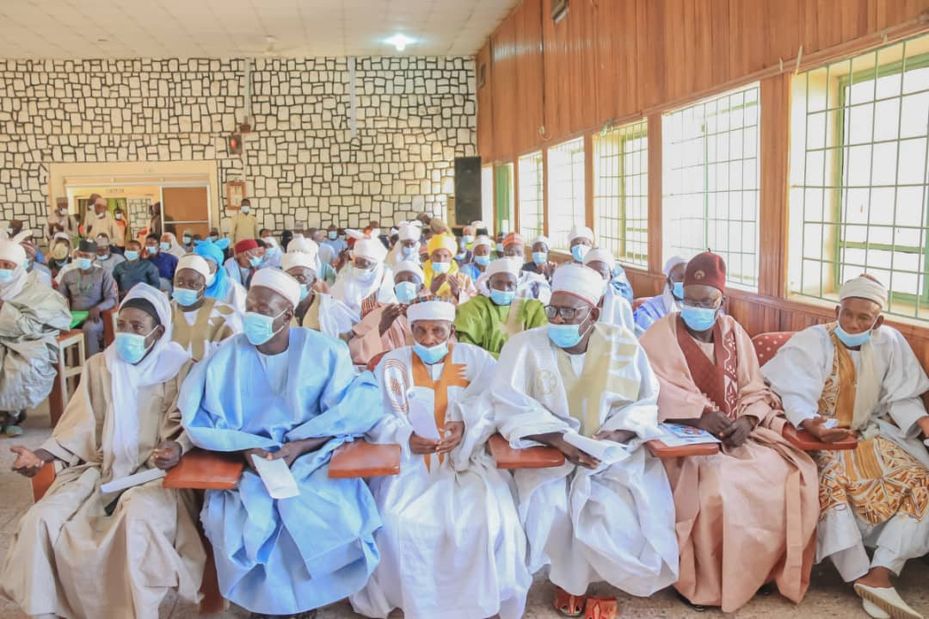
CROSS SECTION OF PARTICIPANTS
- State Government should intensify efforts in assisting farmers to venture into dry season farming considering that the rain farming season is winding up and was bedevilled by floods.
- Commended the state government for accepting the challenges and being proactive in revitalizing the internal revenue board and pledged their support to enhance internal revenue collections in their various domains.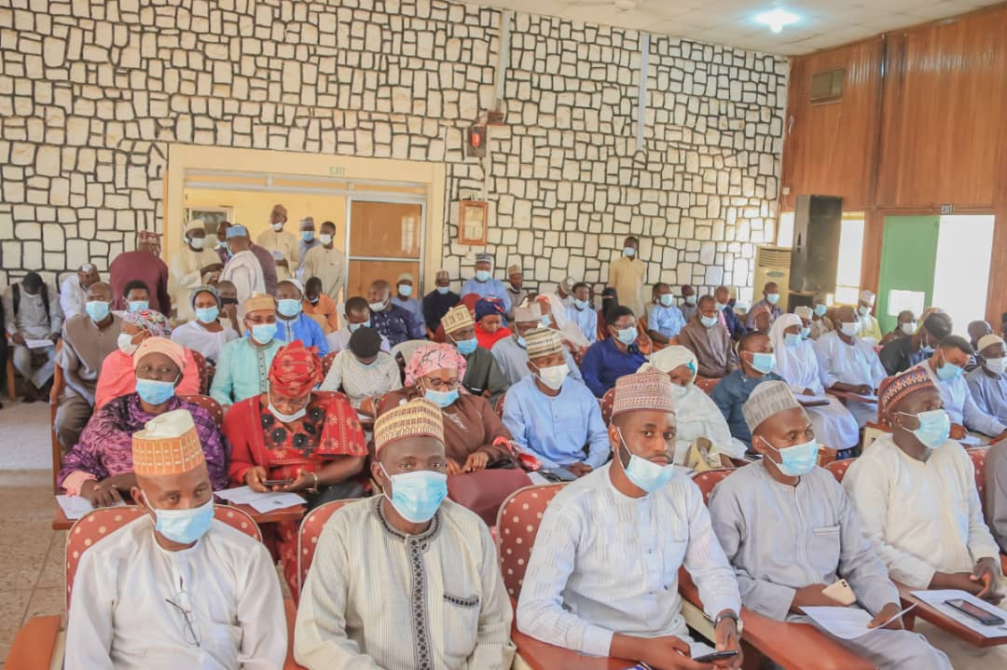
CROSS SECTION OF PARTICIPANTS
- The participants separately and collectively suggested that State Government undertake the following projects as a priority in 2021 among several others thus: -
- Rehabilitate and upgrade Dukku-Wawa–Biri–Wuro Bapparu Road.
- Construction of Deba-Kare-Kare-Dakamma to Garin Abdulahi Road.
- Construction of Ladongor-Sansani-Amtawalam-Pobawawure-Sabon layi-Kulkul-Ayaba Road.
- Constrution of Gadam-Yame-Kurugu-Malam Sidi Road
- Construction of Bojude-Dirri-Bagadaza-Mbarri-Zange to connect Kirfi in Bauchi State.
- Construction of Kumo-Bappa Ibrahim-Luggerowu-Papa Road
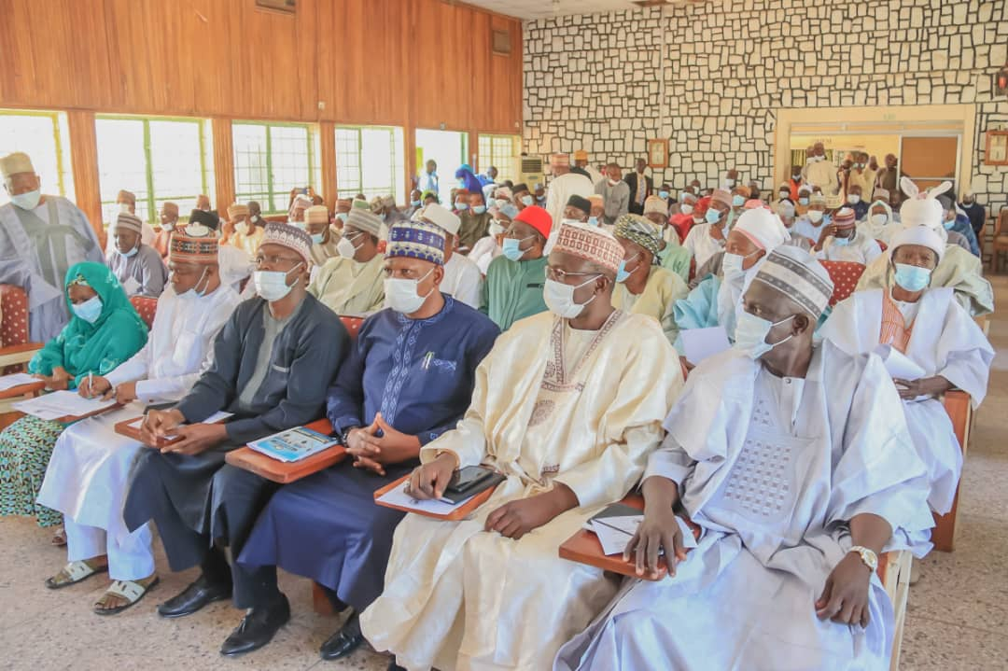
ANOTHER CROSS SECTION OF PARTICIPANTS
7. Closing Remarks by the Chairman who is also the Gombe State Deputy Governor, Mr. Manase Daniel Jatau.
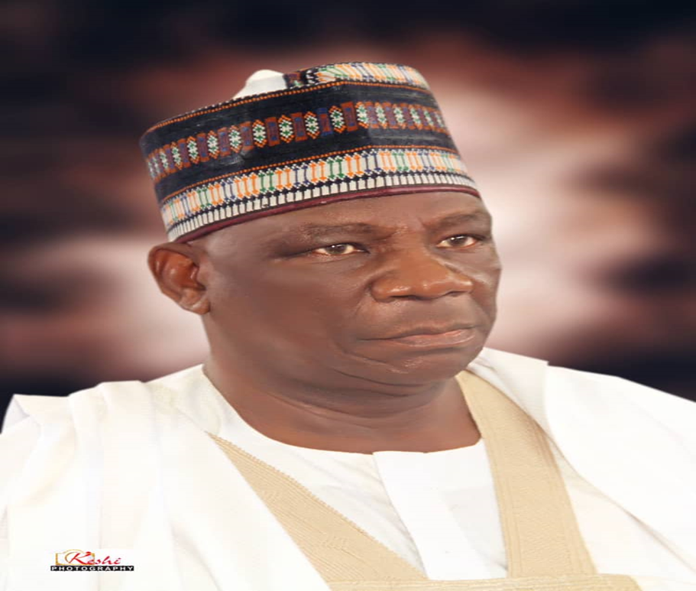
HIS EXCELLENCY, THE DEPUTY GOVERNOR WHO IS ALSO CHAIRMAN OF THE OCCASSION
The Chairman, in his closing remarks stated that;
- The meeting which was aimed at getting feedback/views to ensure that the citizen’ views, opinions and contributions are collated and captured in the 2021 budget is a success. He thanked the participants for honouring the invitation and participating actively.
- He informed the gathering that Gombe State is working out modalities with Federal Ministry of Agriculture and NIRSAL Bank to boost agricultural outputs in the state vigorously through the grant of soft loans and subsidies.
The Chairman while declaring the meeting closed expressed his gratitude to all, assuring them that their contributions are invaluable and will all be considered during the harmonization of the 2021 budget. He wished them all journey mercies back to their various destinations.

Sign: Sign:
Abubakar Dauda Alhassan Yahaya
Director Budget Chairman, MNCH Coalition

