Date of Publication 28 April, 2026

Gombe State Government
Budget IMPLEMENTATION Report QUARTER ONE 2026

Contents
1 Summary of Performance 3
1.A Introduction 3
1.B Revenue Performance 3
1.C Recurrent Expenditure Performance 3
1.D Capital Expenditure Performance 3
1.E Conclusions 3
1.F Summary Budget Implementation Graphs 4
1.G Summary Budget Implementation Report 6
2 Budget Implementation Reports by NCOA Segments 7
2.A Revenue by Administrative Classification 7
2.B Revenue by Economic Classification 8
2.C Expenditure by Administrative Classification 9
2.D Expenditure by Economic Classification 14
2.E Expenditure by Functional Classification 15
2.F Expenditure by Programme Classification 20
3 Capital Expenditure Details 25
4 Primary Healthcare Budget Performance 26
4.A Overview 26
4.B Budget Implementation Reports by NCOA Segment 27
4.C Primary Healthcare Capital Expenditure by Project 28
5 Basic Education Budget Performance 29
5.A Overview 29
5.B Budget Implementation Reports by NCOA Segment 30
5.C Basic Education Capital Expenditure by Project 31

List of Graphical Presentations
Figure 1: Fiscal Performance Overview for Quarter 4
Figure 2: Fiscal Performance Overview Year to Date 5
Figure 3: Summary of Primary Health Care Budget Performance for Quarter and Year to Date 26
Figure 4: Summary of Basic Education Budget Performance for Quarter and Year to Date 29

List of Reports
Table 1: Budget Implementation Summary 6
Table 2: Total Revenue by Administrative Classification 7
Table 3: Total Revenue by Economic Classification 8
Table 4: Total Expenditure by Administrative Classification 9
Table 5: Personnel Expenditure by Administrative Classification 10
Table 6: Overhead Expenditure by Administrative Classification 11
Table 7: Capital Expenditure by Administrative Classification 12
Table 8: Other Expenditure by Administrative Classification 13
Table 9: Total Expenditure by Economic Classification 14
Table 10: Total Expenditure by Functional Classification 15
Table 11: Personnel Expenditure by Functional Classification 16
Table 12: Overhead Expenditure by Functional Classification 17
Table 13: Capital Expenditure by Functional Classification 18
Table 14: Other Expenditure by Functional Classification 19
Table 15: Total Expenditure by Programme Classification 20
Table 16: Personnel Expenditure by Programme Classification 21
Table 17: Overhead Expenditure by Programme Classification 22
Table 18: Capital Expenditure by Programme Classification 23
Table 19: Other Expenditure by Programme Classification 24
Table 20: Capital Expenditure by Project 25
Table 21: Primary Healthcare Expenditure by Administrative Classification 27
Table 22: Primary Healthcare n Expenditure by Functional Classification 27
Table 23: Primary Healthcare Expenditure by Programme Classification 27
Table 24: Primary Healthcare Expenditure by Economic Classification 27
Table 25: Primary Healthcare Capital Expenditure by Project 28
Table 26: Basic Education Expenditure by Administrative Classification 30
Table 27: Basic Education Expenditure by Functional Classification 30
Table 28: Basic Education Expenditure by Programme Classification 30
Table 29: Basic Education Expenditure by Economic Classification 30
Table 30: Basic Education Capital Expenditure by Project 31

Summary of Performance

Introduction
This Budget Implementation Report for Gombe State is prepared quarterly and issued within 28 days from the end of each quarter.
This report includes the original approved budget appropriations for the year 2026 against each organisational unit for each of the core economic classification of expenditures (Personnel, Overheads, Capital, and Others); the actual expenditures for the quarter Q1 attributed to each organisational unit, as well as the cumulative expenditures for year to date, and balances against each of the revenue and expenditure appropriations. This Q1 report is assessed against the 2026 Original Budget.
The core economic classifications, as per the National Chart of Accounts (NCOA) refer to:
- Revenue – Economic Account Type 1
- Personnel Expenditure – Economic Sub-Account Type 21
- Overheads Expenditure - Economic Account Class 2202
- Capital Expenditure - Economic Sub-Account Type 23
- Other Expenditures (covering Loans, Grants and Contributions, Subsidies, Debt Service and Transfer Payments) - Economic Account Classes 2203-2209 as applicable
This report includes sections 4 and 5 detailed reports on Primary Healthcare and Basic Education expenditures, respectively.
This Budget Implementation Report is produced by the Ministry of Budget and Economic Planning and published on the Gombe State website.

Revenue Performance
The overall revenue performance for the quarter was 28.6% of the annual budget. A breakdown of the performance showed that recurrent revenue performance stood at 17.1% of the annual budget, while other receipts represented 5.3%. This positive overall performance is more noticeable with the statutory receipts from FAAC, which was 16.3% of the annual budget. This is apparently due to the deregulation policy and the full implementation of the new fiscal Act of 2026 by the Federal Government of Nigeria, which significantly improved the State government revenue. During the quarter one under review, the State generated 22.8% of the budgeted independent revenue for the year. A breakdown of the receipts showed that revenue receipts through taxes were 26.0% of the budgeted figure, while non-tax receipts generated were 21.1% of the year’s budget. These were achieved through improved and automated local revenue generation drive through widening the tax net and capacity building of revenue Staff. Hopefully, this will be sustained through continuous sensitisation and regular capacity building of revenue service’s staff on the implementation and adoption of the new tax regime.
Upfront on other receipts breakdown, foreign borrowing to finance the budget was 3.8% of the budgeted amount.

Recurrent Expenditure Performance
Overall, recurrent expenditure performance for the quarter was 14.9% of the annual budget for this category. This performance consists of 19.9% of the annual budget for personnel cost (which was made up of 16.4% budget performance for social benefits expenditure), while 13.0% of the annual budget was expended on other over-head cost. Within this category, public debt charge payments represented 30.8% of the budgeted figure (about N9,651,335,651.28 billion payments for domestic principal and interest payments stood at N7.2 billion and N2.4 billion for foreign principal repayments).

Capital Expenditure Performance
Capital expenditure performance for the Q1 period was 8.4% of the budget for this category, this relatively poor performance can be attributed to the slow start of activities in the first quarter of the year. A breakdown of the performance shows the following:
• Administrative sector – 12.0% budget performance
• Economic sector – 7.6% budget performance
• Law and Justice – 0.0% budget performance
• Social sector – 10.0% budget performance

Conclusions
In line with the commitment of the Governor of Gombe State, the Q1 budget performance was tailored towards consolidation and completion of critical infrastructure either inherited or initiated since the assumption of office of the current administration in the State as well as continue investments in education and other critical areas of socio-economy facet of its citizenry, which includes human capital development and empowerment of youth and women. Given this first quarter performance, we are hoping for better budget performance for the period ahead.
Under Ecological fund and Grants there was no any expenditure reported from the DA concern during the Q1
Concerning the zero expenditure performance on overhead and capital, there was no expenditure reported within the quarter.
For the higher revenue generated (of up to 28%) with lower expenditure of only 10%. The reason is that there was no much expenditure in the first which is ideal.
On the issue of low interest earned, the interest on opening balance was already reported in Q4 2025. This 8 Million is only for Q1 2026
The over expenditure on the office of the Head of Civil Service is due the Completion of permanent NYSC Orientation Camp by the state in which ₦30,000,000 was approved while about ₦1.6 billion was spent. In addition, any other over expenditure by MDAs will be financed during budget amendments.
On the issues of expenditure on Contingency, Construction/ Provision of Air-Ports/Aerodromes and Rehabilitation/Repairs – Railways it was the issue of coding which will also be corrected in the subsequent quarter

Summary Budget Implementation Graphs
Figure 1: Fiscal Performance Overview for Quarter

Figure 2: Fiscal Performance Overview Year to Date

Summary Budget Implementation Report
Table 1: Budget Implementation Summary

Budget Implementation Reports by NCOA Segments

Revenue by Administrative Classification
Table 2: Total Revenue by Administrative Classification

Revenue by Economic Classification
Table 3: Total Revenue by Economic Classification

Expenditure by Administrative Classification

Table 4: Total Expenditure by Administrative Classification
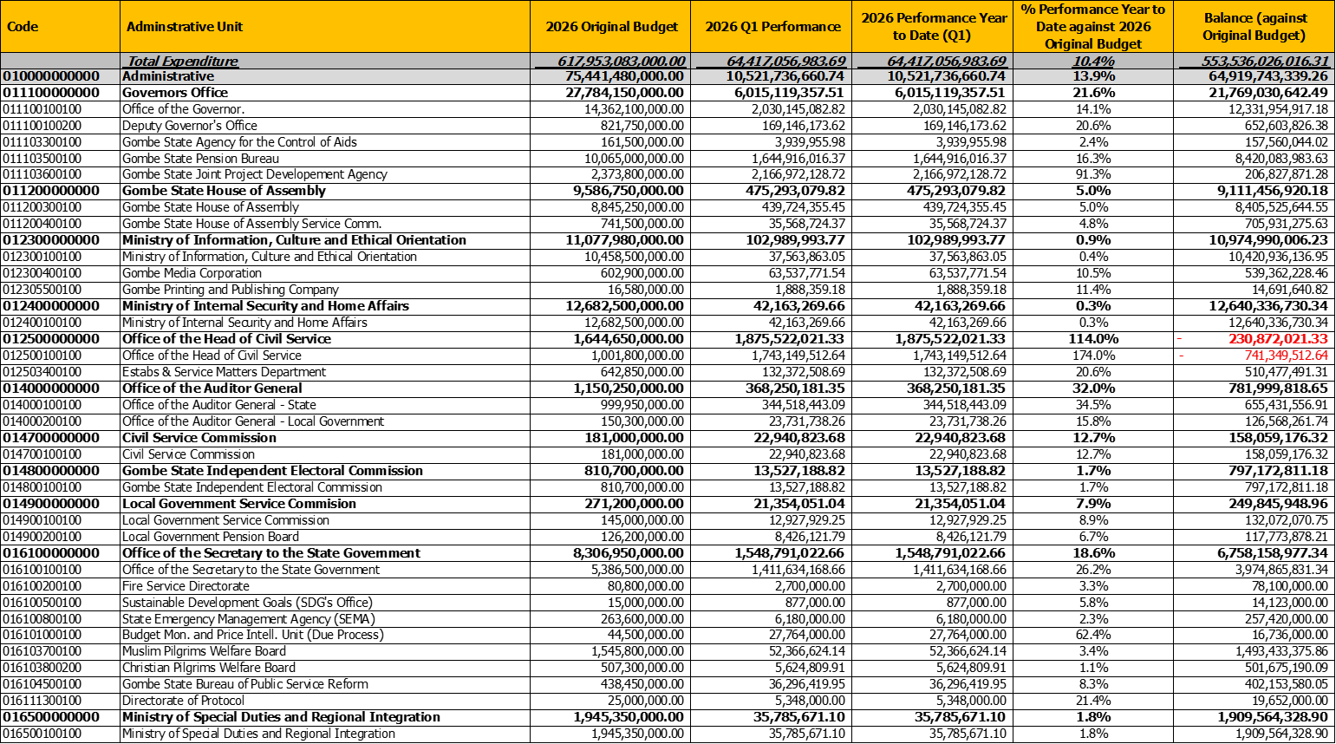

Table 5: Personnel Expenditure by Administrative Classification
Table 6: Overhead Expenditure by Administrative Classification
Table 7: Capital Expenditure by Administrative Classification

Table 8: Other Expenditure by Administrative Classification

Expenditure by Economic Classification
Table 9: Total Expenditure by Economic Classification

Expenditure by Functional Classification
Table 10: Total Expenditure by Functional Classification

Table 11: Personnel Expenditure by Functional Classification

Table 12: Overhead Expenditure by Functional Classification

Table 13: Capital Expenditure by Functional Classification
Table 14: Other Expenditure by Functional Classification

Expenditure by Programme Classification
Table 15: Total Expenditure by Programme Classification
Table 16: Personnel Expenditure by Programme Classification

Table 17: Overhead Expenditure by Programme Classification

Table 18: Capital Expenditure by Programme Classification

Table 19: Other Expenditure by Programme Classification

Capital Expenditure Details
Capital Expenditure Projects related to Primary Healthcare have a blue marker whilst those related to Basic Education have a green marker.
Table 20: Capital Expenditure by Project

Primary Healthcare Budget Performance

Overview
As The overall Q1 budget performance for the PHC stood at 0.2%. This was made up of 19.9% budget outturn for the personnel costs, while the overhead cost performance budget was 0.2%. Capital Expenditure budget performance for the first quarter, year to date, stood at 0.0%of the annual capital budget. There was no expenditure at the first quarter which may be to some thinks does not taken shape during the quarter.
A summary of the performance Year to Date (YTD) against the original budget is provided below for the main economic classifications of expenditure, and YTD against the programme segment (Objective level). Note that the performance metrics in the reports in section 4.B and 4.C are based on the latest version of the budget (this may not be the original budget, it may be the revised or final budget).
Figure 3: Summary of Primary Health Care Budget Performance for Quarter and Year to Date

Budget Implementation Reports by NCOA Segment
Table 21: Primary Healthcare Expenditure by Administrative Classification
Table 22: Primary Healthcare Expenditure by Functional Classification
Table 23: Primary Healthcare Expenditure by Programme Classification

Table 24: Primary Healthcare Expenditure by Economic Classification

Primary Healthcare Capital Expenditure by Project

Table 25: Primary Healthcare Capital Expenditure by Project

Basic Education Budget Performance

Overview
The Q1 budget performance for the Basic Education (BED) subsector stood at 57.4%. This consist of 23.8% budget outturn for the personnel costs, while overhead cost performance budget was 3.8%. Capital Expenditure budget performance for the quarter stood at 59.1% of the annual capital budget for the BED. It was equally noted that budgets for purchase of fixed assets and constructions been exhausted while some nearly got exhausted with (1050.0% and 88.3% respectfully).
Note that the performance metrics in the reports in section 5.B and 5.C are based on the latest version of the budget (this may not be the original budget, it may be the revised or final budget).
Figure 4: Summary of Basic Education Budget Performance Year to Date

Budget Implementation Reports by NCOA Segment
Table 26: Basic Education Expenditure by Administrative Classification
Table 27: Basic Education Expenditure by Functional Classification
Table 28: Basic Education Expenditure by Programme Classification
Table 29: Basic Education Expenditure by Economic Classification

Basic Education Capital Expenditure by Project
Table 30: Basic Education Capital Expenditure by Project

